Bahria University,

Karachi Campus

LAB EXPERIMENT NO.

___11___

LIST OF TASKS

|  |  |
| --- | --- |
| TASK NO | OBJECTIVE |
| 1 | consuming BANK microservices. |
| 2 | consuming Product micro services. |

Submitted On:

20-06-2023

(Date: DD/MM/YY)

**LAB 11**

Task1: consuming BANK microservices.

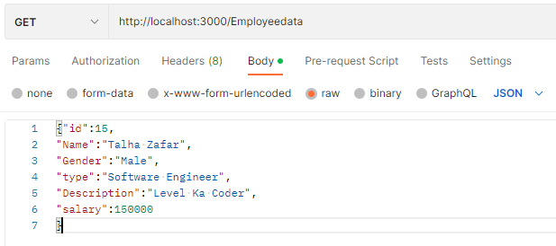

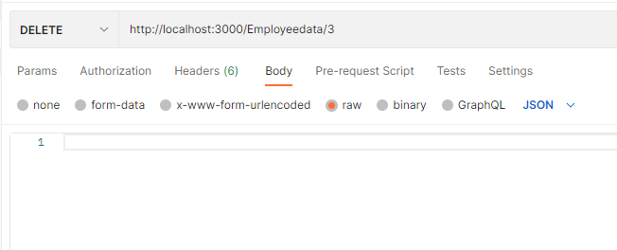

Task2: consuming Product micro services.



